**RADV**

**Risk Adjustment Data Validation Tool**



**Software Documentation and User Guide**

**April 2016**

**FHIRed_Up**

Augusto Burgos [aburgos3@gatech.edu](mailto:aburgos3@gatech.edu)   
Spiro Ganas [spiroganas@gmail.com](mailto:spiroganas@gmail.com)   
Anja Guillory [anjag1993@gmail.com](mailto:anjag1993@gmail.com)   
Jamie Richgels [jrichgels3@gatech.edu](mailto:jrichgels3@gatech.edu)   
Daniel Stoneburner [dstoneburner3@gatech.edu](mailto:dstoneburner3@gatech.edu)   
Tala Suidan [tmsuidan@gatech.edu](mailto:tmsuidan@gatech.edu)

**Table of Contents**

**Statement of Goals** 1

**Background Information** 1

**Functional Description** 2

**Future of the Application** 2

**System Architecture** 3

**System Requirements** 3

**User Interface** 3

**Acronyms & Abbreviations** 4

**User Access Levels** 4

**Constraints** 5

**Using RADV** 5

Login 5

Patient Lookup 5

Patient Display 6

Viewing Current Year HCCs 8

Viewing Candidate HCCs 9

Adding an HCC 10

Rejecting HCCs 11

Look up another patient 14

Logout 14

Data Recording 14

**References** 15

# **Statement of Goals**

The Affordable Care Act requires health insurance companies to offer insurance to people with pre-existing conditions. By only offering policies with high co-pays and high-deductibles, insurance companies can discourage ill patients from purchasing their products. Risk adjustment prevents this by transferring premiums from insurers with healthy members to those organizations that are insuring for a more ill population.

Risk scores are used to determine the average level of illness in an insurers’ population. A risk score is calculated using the list of diagnoses recorded for a patient during the previous calendar year and is a relative score against the average patient (risk score for an average patient=1). This gives providers and insurers a strong financial interest in making medical records accurate and complete.

The RADV tool was designed to help providers validate medical records by identifying health care conditions that may be missing from a patient’s recent medical record.

# **Background Information**

Risk Scores are an estimate of an individual’s future medical costs. Recent diagnostic history is the most important data in determining an individual’s risk score. Other predictors include the individual’s geographic area, age/gender and the type of insurance policy (high-deductible, low co-pays, etc.)

Risk Selection occurs when insurers try to avoid enrolling unhealthy people by making their products unattractive to people requiring costly medical care.

Risk Adjustment discourages risk selection by transferring premiums from insurers with healthy members to those with members who are more ill.

If a member has an illness, but the diagnosis code is not reported to the insurance carrier during the calendar year, their risk score will be artificially low.

This data quality issue can substantially reduce an insured's premiums. When provider payments are on a percent-of-premium basis, it also reduces payments to hospitals and doctors.

As doctors and hospitals move to a pay-for-performance structure, correct risk assessment and diagnostic codes ensure appropriate payment for treatment of patients with multiple chronic diseases.

The American Health Lawyers Association recommends the following strategies:

* Know high revenue HCCs that are often undiagnosed or undercoded
* Review missing diagnoses from prior years’ HCCs and send reminders to MDs
* Audits of records vs. codes for missing codes: last year and this year.
* Conduct annual comprehensive exams for members who have not yet been seen early in the year.

Example of Risk Score Error and consequences:

68-year-old man with pneumonia, emphysema, diabetes with retinopathy, and respiratory failure has the following risk profile

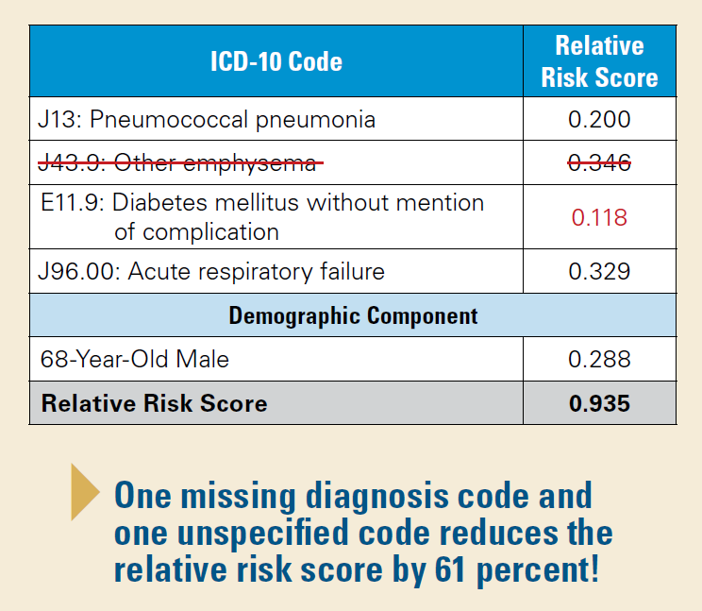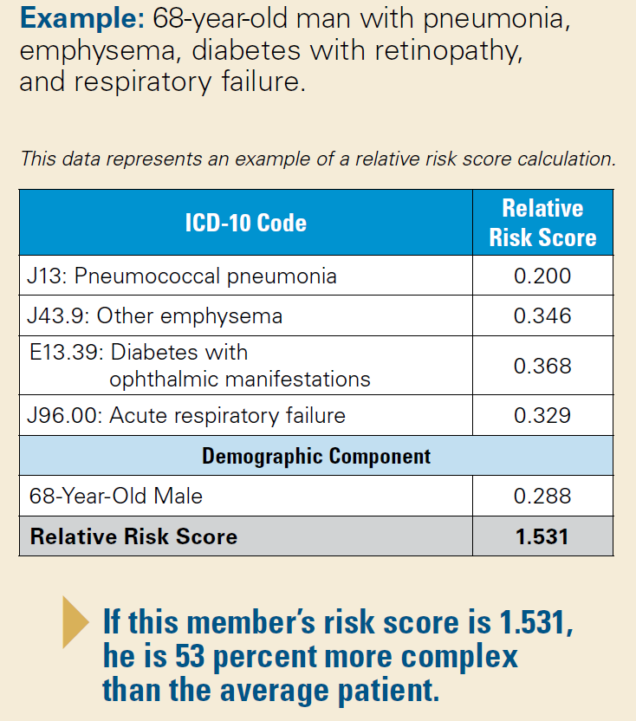

Source: https://www.bcbsal.org/providers/pdfs/riskAdjustment.pdf

# **Functional Description**

For systems that use a Fast Healthcare Interoperability Resources (FHIR) Server or another centralized data source, RADV allows clinical staff and doctors to search a patient’s available clinical history for any conditions that are not listed in the current year. Upon finding any missing conditions or hierarchical condition categories (HCCs), clinical staff can add the HCC to the patient’s record. This facilitates accurate risk scoring and financial accounting and payments.

# **Future of the Application**

We hope to enter it in the HealthIT Techlab: Innovation Contest

# **System Architecture**

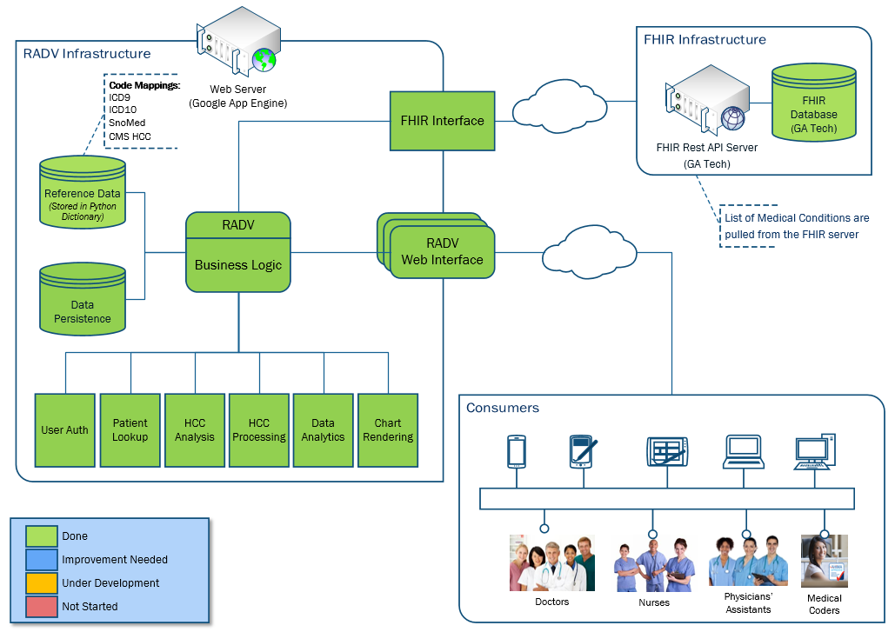

# **System Requirements**

RADV itself has been built in Google App Engine and system requirements are deferred to needing to be deployed in that Platform.

In order for a user to gain access to the RADV tool they will need a machine with a modern operating system installed (tested on Windows 8, Windows 10, OS X, Ubuntu 16.04, CentOS 7, and Chrome OS) with a modern browser installed (tested on Internet Explorer 11, Safari, Firefox, Chrome, and Microsoft Edge. The minimum specs tested 4 GB of RAM and a dual core 1.70 GHz processor although lower specifications should also work as the client machine does not perform processing in the application.

# **User Interface**

RADV is accessible via <https://focus-appliance-122323.appspot.com/login>. It connects to and directly parses the Georgia Institute of Technology’s FHIR server. Original wireframes are displayed below.

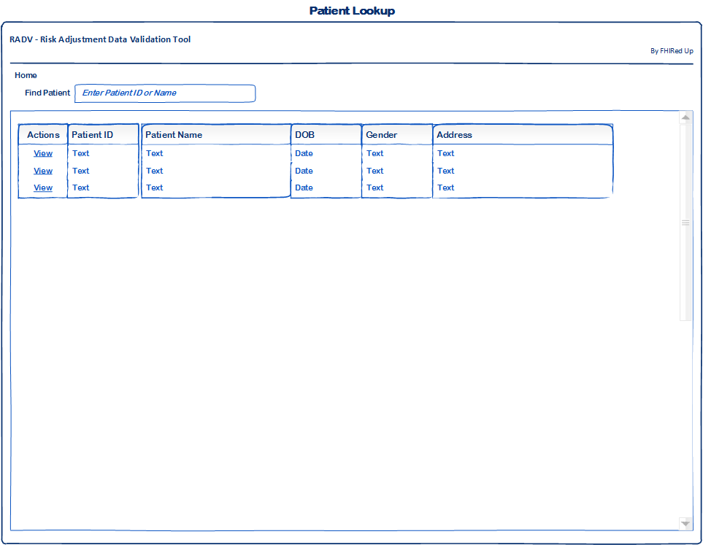 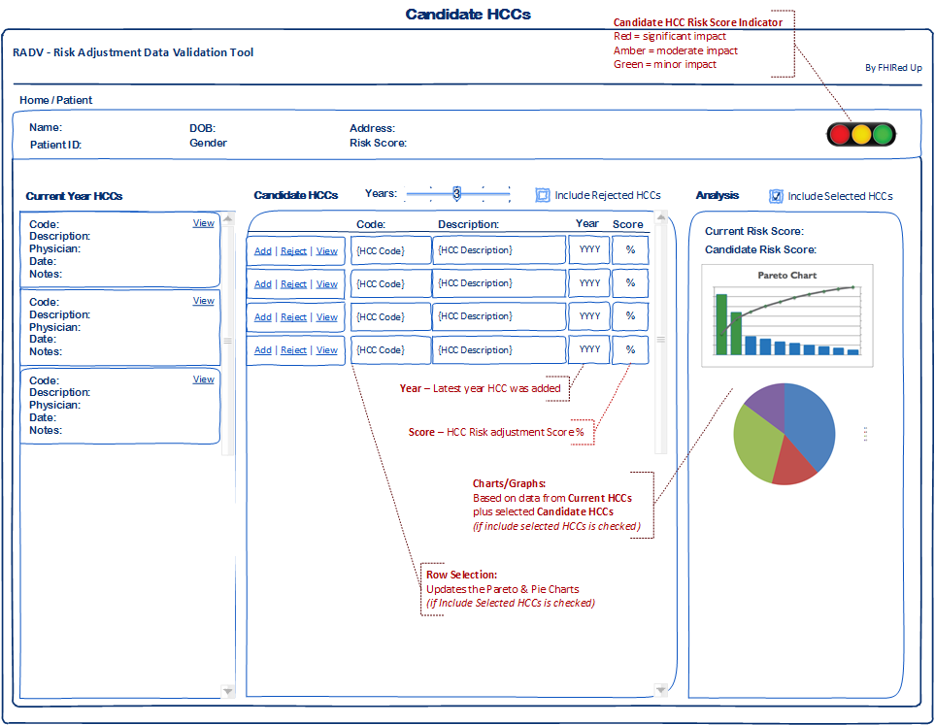

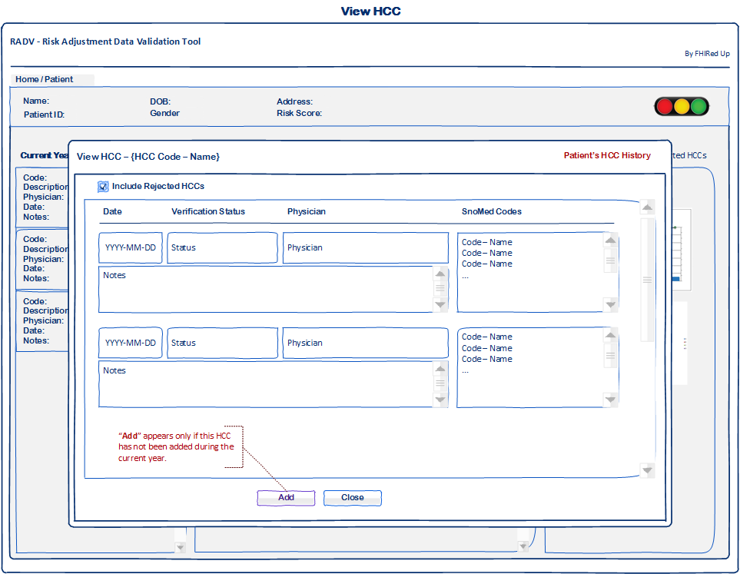 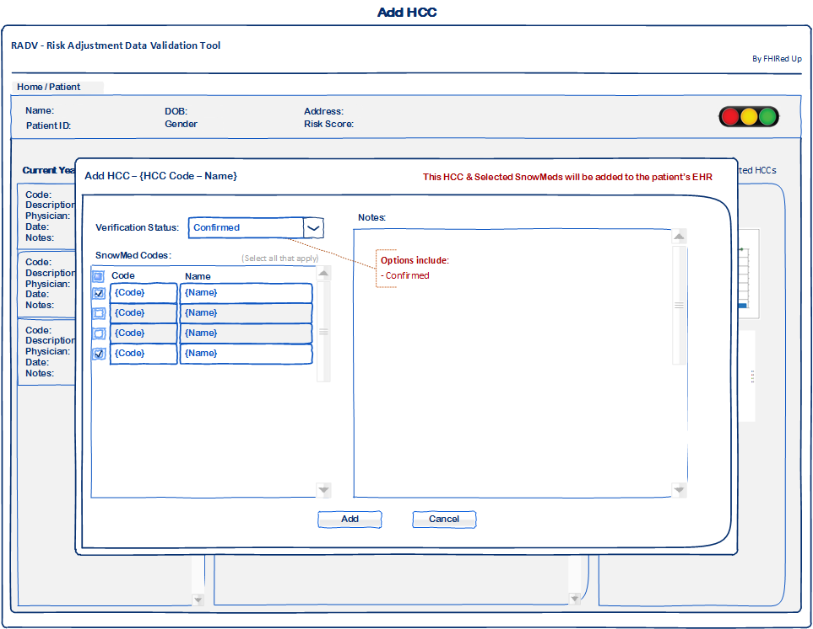

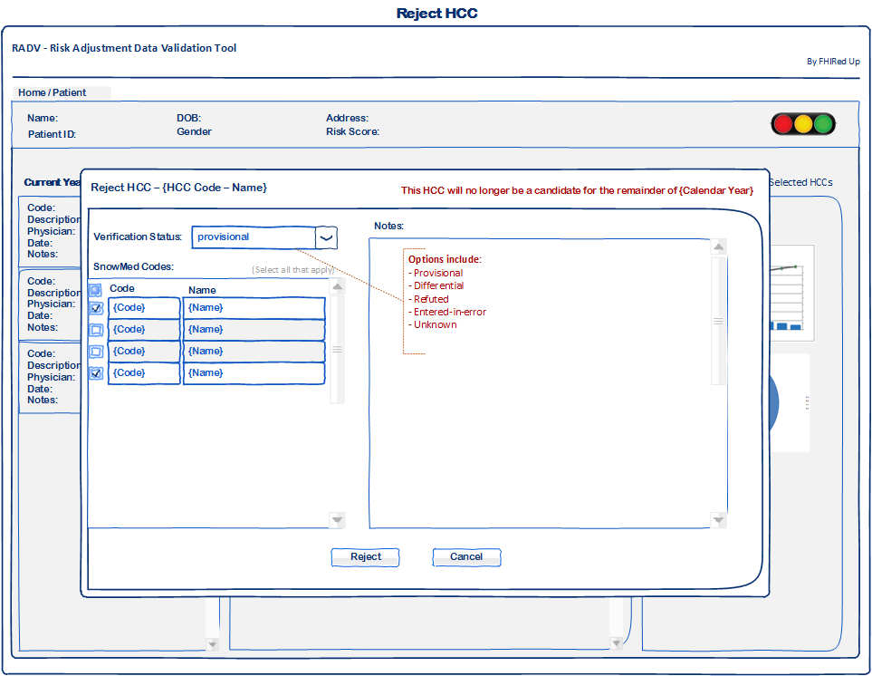

# **Acronyms & Abbreviations**

|  |  |
| --- | --- |
| EHR | Electronic Health Record |
| FHIR | Fast Healthcare Interoperability Resources |
| HCC | Hierarchical Condition Categories |
| RADV | Risk Adjustment Data Validation |
| SNOMED | Systematized Nomenclature of Medicine |

# **User Access Levels**

All users have the same permissions in this implementation.

# **Constraints**

* A real-world implementation would employ Role Based Access Control or other permissions and workflows to ensure that a medical doctor confirms all additions or deletions to patient’s Electronic Health Record in the FHIR server.
* The application server’s cache is flushed automatically every 5 minutes to ensure the patient’s record is obtained with the most recent information.
* There is a persistence API to store all changes made through RADV. A real world application would add data to the FHIR server itself, making entries on the FHIR server’s audit trail.
* There is limited patient data in the FHIR server used. Patients 4 and 725 have entries that demonstrate features of the RADV application.

# **Using RADV**

## Login

Using your web browser, navigate to <https://focus-appliance-122323.appspot.com/login>.

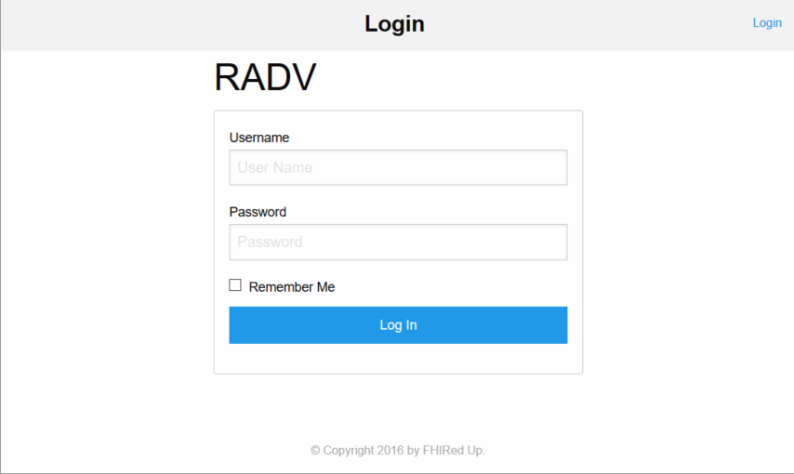

Login using username, FHIRedUp, and password, PjV7kGTD.

Patient Lookup

The Patient lookup screen should display. A user can search by patient name or by patient ID by selecting the appropriate radio button. This user guide employs patient 4 for examples.

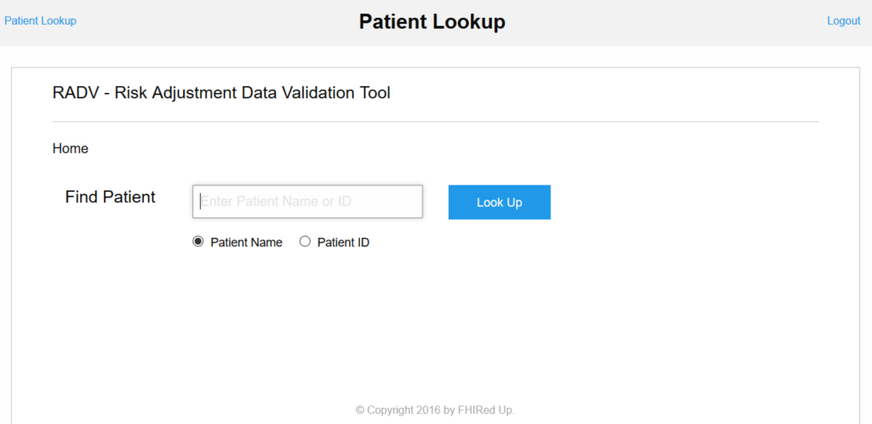

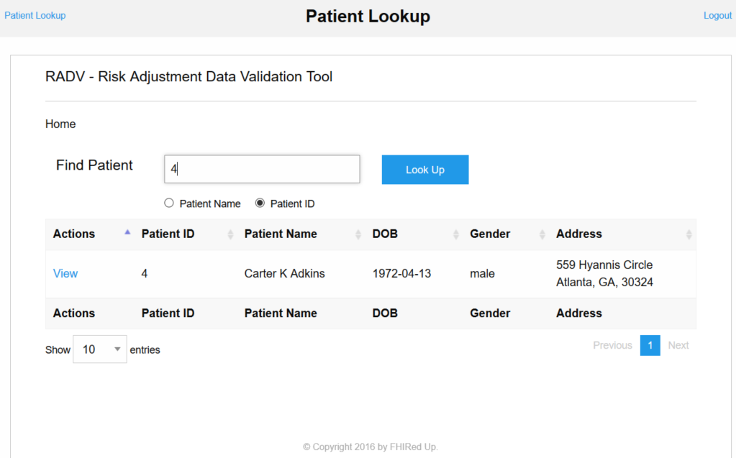

On each internal page, the Patient lookup and logout links are displayed in the top left and right corners. Any active links are displayed in blue. Selection buttons are displayed as blue buttons with white text as the look up button above.

## Patient Display

To select a patient, click on the view hyperlink. The patients record displays with their information at the top, their current year’s Hierarchical Condition Categories (HCCs) on the left pane, the candidate missing HCCs in the middle panel with each HCC’s risk score, the year in which it previously appeared on the patient’s EHR, the HCC code, and a link for adding to or rejecting from the patient’s EHR. The Risk score information and graphical display appear on the right panel with the ability to see the impact of adding the candidate HCCs.

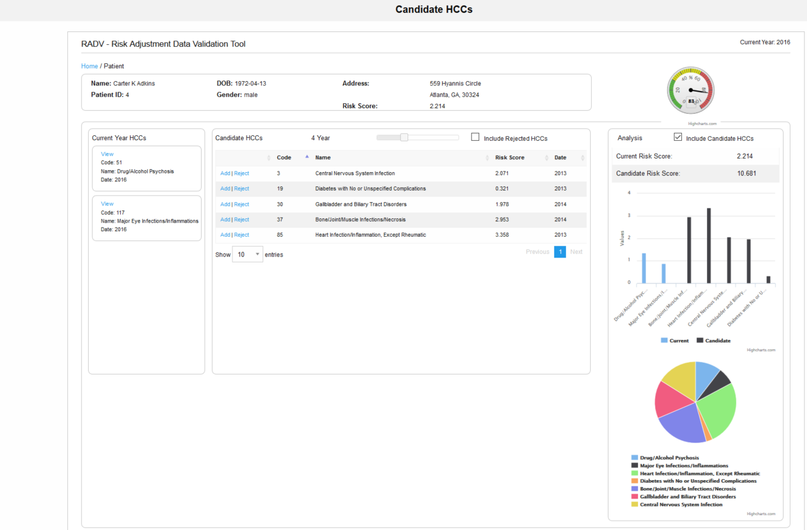

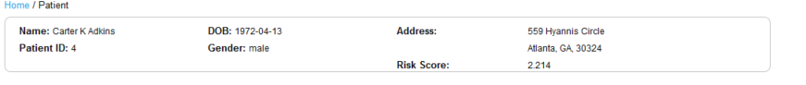

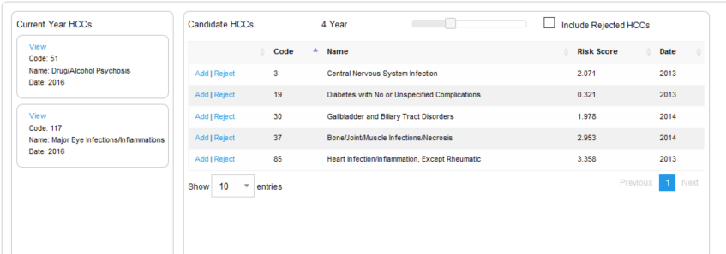

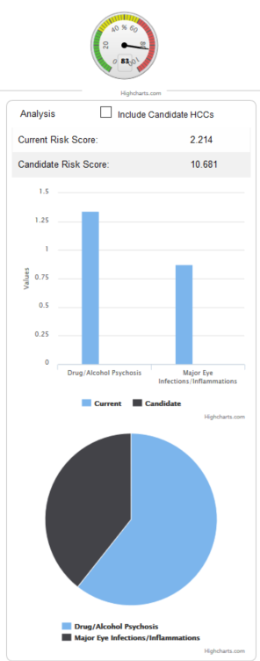 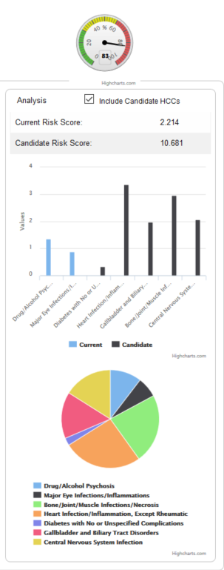

## Viewing Current Year HCCs

To view information on a current year HCC, click on the View link for a particular condition.

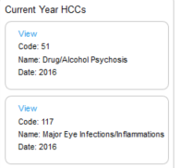

A new window should open displaying the Code’s status for that patient and the related SNOMED codes which were entered and translated to that HCC.

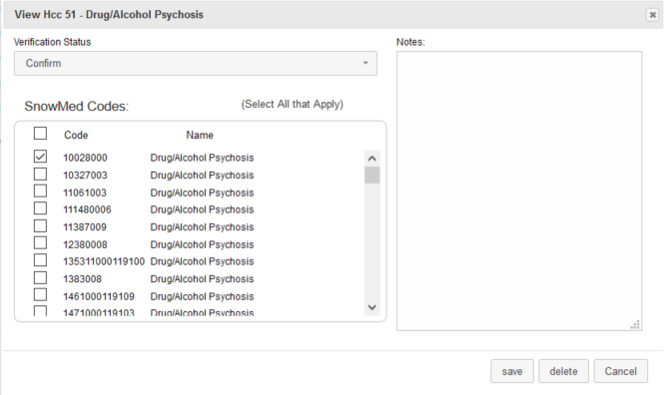

A user may delete, but we advise that in a real-world implementation, only a doctor may perform this action while making supporting documentation.

## Viewing Candidate HCCs

The center panel displays HCCs that were entered on the patient’s EHR in previous years. Four years is the default, and a user may adjust the time by sliding the bar at the top of the panel.

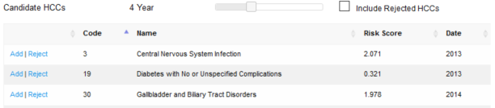

## Adding an HCC

To add an HCC to a patient’s EHR, select the add link to the left of the specific HCC.



A new window should open allowing the user to select corresponding SNOMED codes, the verification status which should be confirmed by default, and to enter supporting reasons.

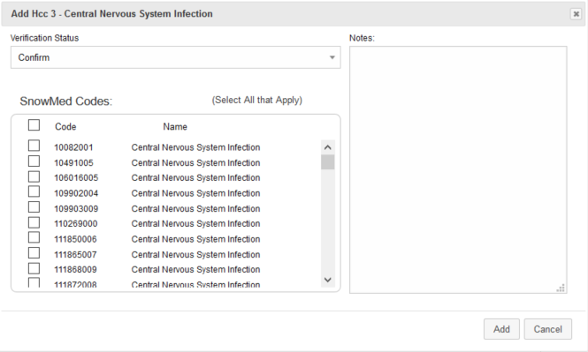

Once added the graphical display at the right automatically updates showing the current HCCs in blue and candidate HCCs in black. The pie chart displays the percentage each HCC contributes to the total. To display the percentage, hover over the pie slice.

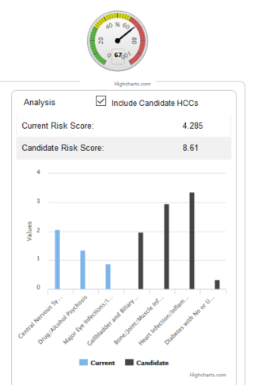 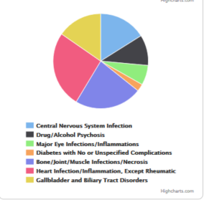

## Rejecting HCCs

A user may also reject HCCs which are not accurate or no longer affect the patient although they appear in their EHR for previous years. The user has the option of displaying HCCs which have already been rejected that year in case there was an error.

To reject, a user clicks on the reject link to the left of the HCC.

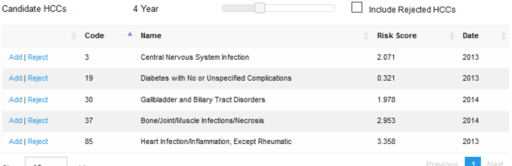

A new window opens with showing corresponding SNOMED codes, a default verification status of refuted, and a free text field for notes.

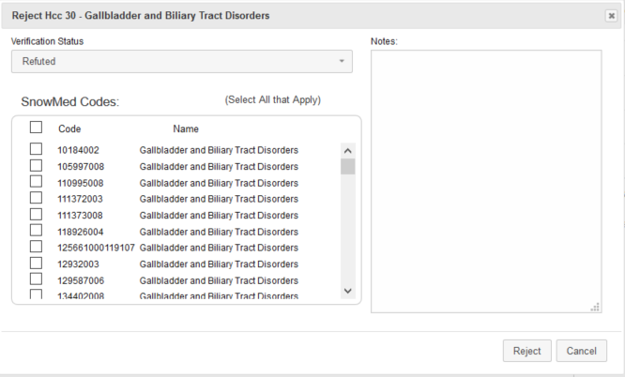

To complete rejection, enter notes and select reject.

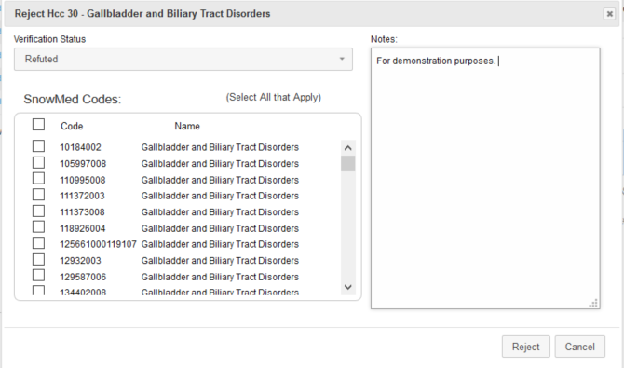

The HCC no longer appears in the candidate HCC list unless include Rejected HCCs is displayed. The graphs at th right are updated a well.

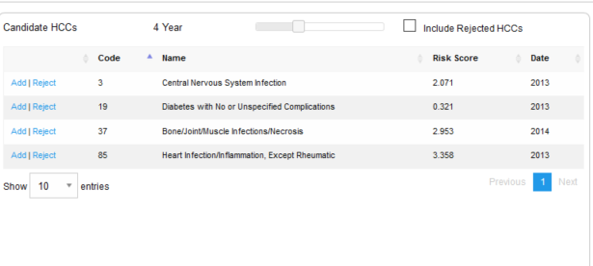 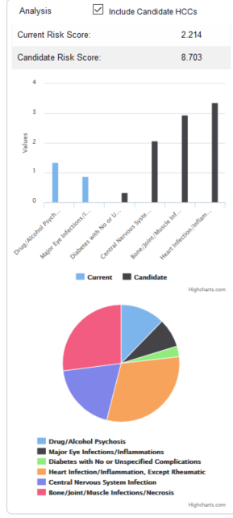

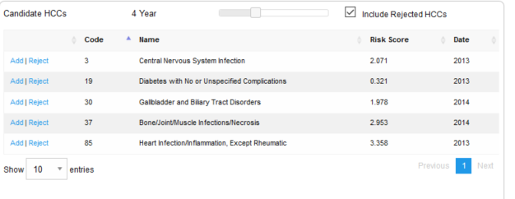 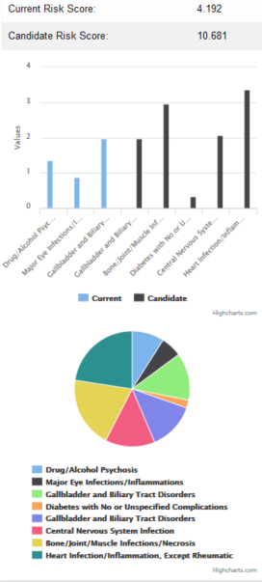

## Look up another patient

To look up another patient click the blue hyperlink in the top left of the window that says patient lookup. This will return the user to the patient lookup screen.

## Logout

To logout, click the blue “logout” hyperlink in the top right of the screen.

## Data Recording

All data entries are recorded via a persistence API without additional steps from the user. As stated in constraints, a real world implementation would make changes on the FHIR server under the current encounter and be recorded in the FHIR server’s audit trail.

# **References**

Class Lectures

<https://www.bcbsal.org/providers/pdfs/riskAdjustment.pdf>

<https://www.healthlawyers.org/Events/Programs/Materials/Documents/MM12/papers/EE_haley_sillman_slides.pdf>

<http://www.modernhealthcare.com/article/20150701/NEWS/150709989>

<http://kff.org/health-reform/issue-brief/explaining-health-care-reform-risk-adjustment-reinsurance-and-risk-corridors/>

Images from

<http://decompressionprosmarketing.com/blogs/decompression-pros/16891112-how-to-ask-for-referrals-from-medical-doctors>

<http://www.libertynursingagency.com/>

<http://allhealthcare.monster.com/training/articles/1822-5-steps-to-becoming-a-medical-assistant>

<http://greenfieldcc.3dcartstores.com/Medical-Coding-and-Billing_p_1058.html>